**DAILY ONLINE ACTIVITIES SUMMARY**

|  |  |  |  |  |  |  |  |  |
| --- | --- | --- | --- | --- | --- | --- | --- | --- |
| **Date:** | **26/05/2020** | | | | | **Name:** | **Manish B Shriyan** | |
| **Sem & Sec** | **8th sem B sec** | | | | | **USN:** | **4AL16CS131** | |
| **Online Test Summary** | | | | | | | | |
| **Subject** | | **BDA** | | | | | | |
| **Max. Marks** | | **40** | | **Score** | | | **30** | |
| **Certification Course Summary** | | | | | | | | |
| **Course** | **AWS Cloud Practitioner Essentials(Second Edition): AWS Architecture** | | | | | | | |
| **Certificate Provider** | | | **AWS** | | **Duration** | | | **1 Hour 20 mins** |
| **Coding Challenges** | | | | | | | | |
| **Problem Statement:**  **Enter the Input String: abcd**  **Expected Result: Pointer : Generate permutations of a given string :**  **The permutations of the string are : abcd abdc acbd acdb adcb adbc bacd badc bcad bcda bdca bdac cbad cbda cabd cadb cdab cdba dbca dbac dcba dcab dacb dabc** | | | | | | | | |
| **Status: Solved** | | | | | | | | |
| **Uploaded the report in Github** | | | | | **Uploaded** | | | |
| **If yes Repository name** | | | | | **ManishShriyan** | | | |
| **Uploaded the report in slack** | | | | | **Yes** | | | |

Online Test Details:

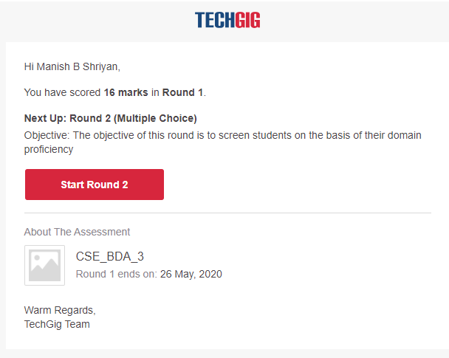

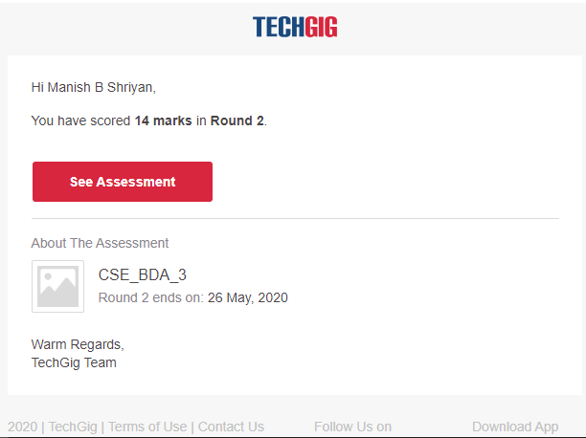

Certification Course Details:

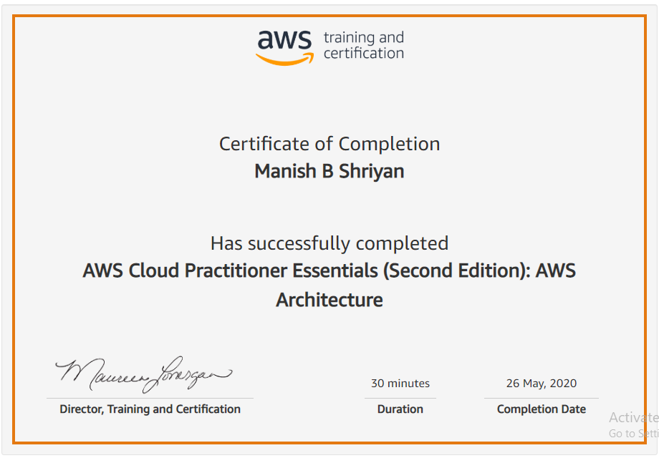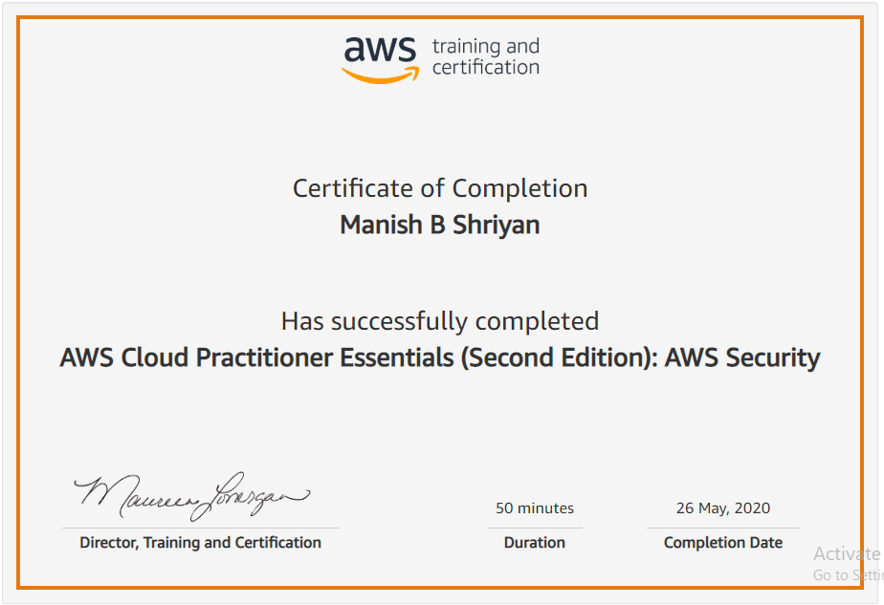

Coding Challenges Details:

#include <stdio.h>  
#include <string.h>

void swap (char *x, char *y)  
{  
char temp;  
temp = *x;  
*x = *y;  
*y = temp;  
}  
/* End of swap() */

/* Function to print permutations of string */  
void permute(char *a, int i, int n)  
{  
int j;  
if (i == n)  
printf("%s\n", a);  
else {  
for (j = i; j <= n; j++)  
{  
swap((a + i), (a + j));  
permute(a, i + 1, n);  
swap((a + i), (a + j)); //backtrack  
}  
}  
}

/* The main() begins */  
int main()  
{  
char a[20];  
int n;  
printf("Enter a string: ");  
scanf("%s", a);  
n = strlen(a);  
printf("Permutaions:\n");  
permute(a, 0, n - 1);  
getchar();  
return 0;  
}